Ideation Phase
Brainstorm & Idea Prioritization Template
Date | 28 September 2026
Team ID | 6ab221d587602313e82c60c9
Project Name | Import data using transform maps (spreadsheet)
Maximum Marks | 4 Marks
Brainstorm & Idea Prioritization Template:
Brainstorming provides a free and open environment that encourages everyone within a team to participate in the creative thinking process that leads to problem solving. Prioritizing volume over value, out-of-the-box ideas are welcome and built upon, and all participants are encouraged to collaborate, helping each other develop a rich amount of creative solutions.
Use this template in your own brainstorming sessions so your team can unleash their imagination and start shaping concepts even if you're not sitting in the same room.
Step-1: Team Gathering, Collaboration and Select the Problem Statement
Team gathering | Team members meet (online or offline) to discuss the difficulties faced while importing spreadsheet data, and agree on one problem to solve.
Problem statement | Entering spreadsheet (Excel/CSV) data manually into tables is slow and error-prone. How can we import spreadsheet data accurately and automatically into the target table by mapping its columns to table fields using transform maps?
How might we | How might we load spreadsheet data through an import set and transform map in less time and without errors?

Step-2: Brainstorm, Idea Listing and Grouping
Brainstorm: each team member writes down ideas for the problem statement.
Member 1 | Member 2 | Member 3 | Member 4
Upload the Excel file as a data source | Create field maps: source column → target field | Clean data with onBefore/onAfter transform scripts | Review import log and error rows, then fix them
Create an import set table from the file | Use Coalesce to avoid duplicate records | Run a test import with sample data first | Make a standard spreadsheet template for the team
Group ideas: similar ideas are clustered together and given a name.
Group 1: Data Preparation | Group 2: Mapping & Transformation | Group 3: Testing & Monitoring
Standard spreadsheet template | Data source & import set table | Test import with sample data
Data format validation | Field maps (transform map) | Import log review
Duplicate check | Transform scripts, Coalesce | Fix failed records

Step-3: Idea Prioritization
Ideas are placed on the grid by Importance and Feasibility. Ideas in the top-right corner are the ones to take forward.
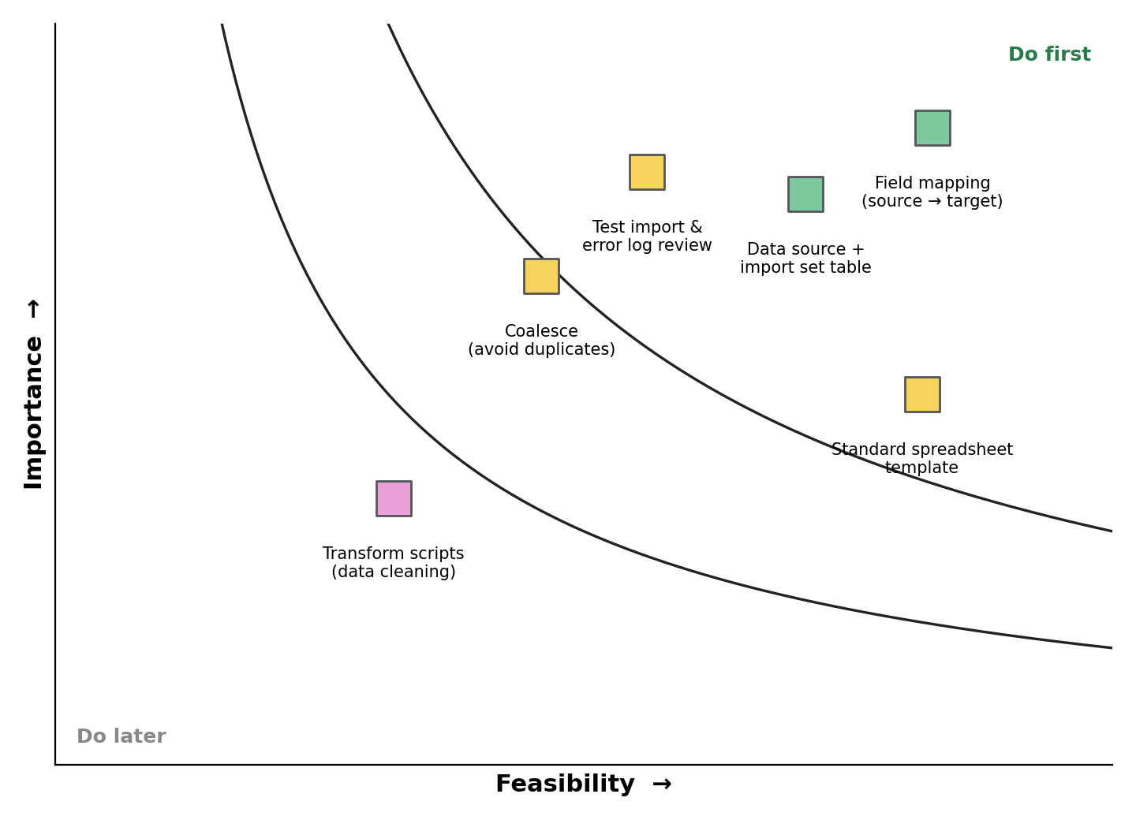
Selected ideas:
Data source and import set table setup, field mapping through the transform map, and Coalesce for duplicate handling.

